Robotics testing:

testing the A* search:

start position [0][19] end position [9][2]
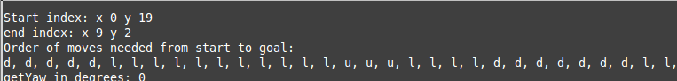

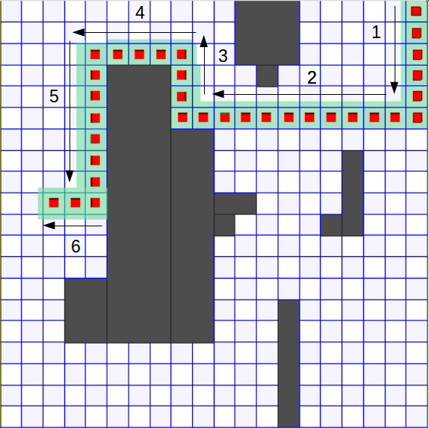

start position [0][10] end position [17][6]

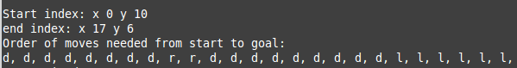

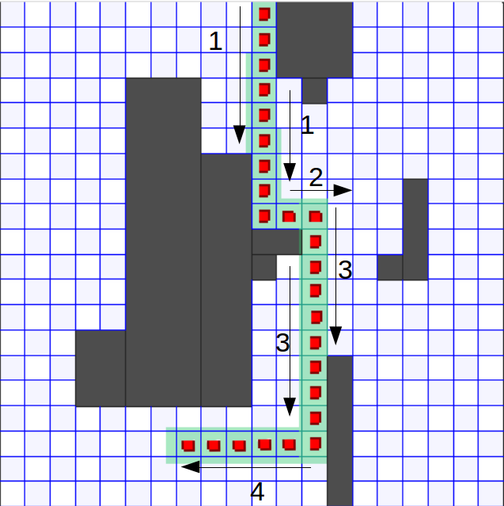

start position [0][0] end position [19][0]

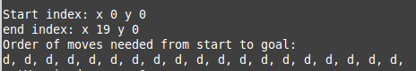

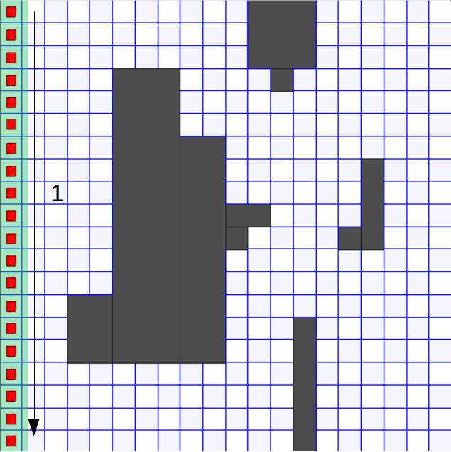

start position [11][10] end position [12][4]
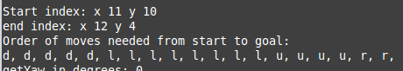

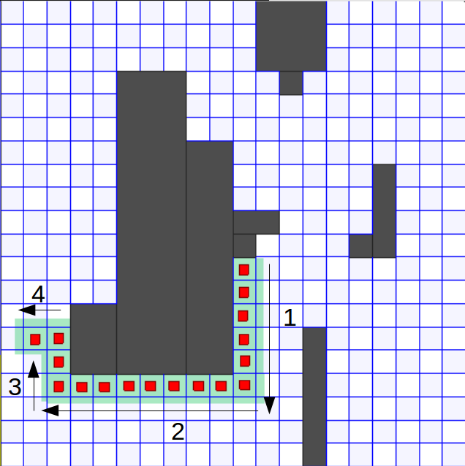

start position [18][16] end position [14][1]

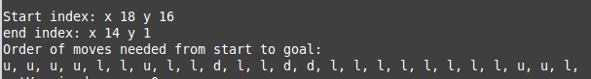

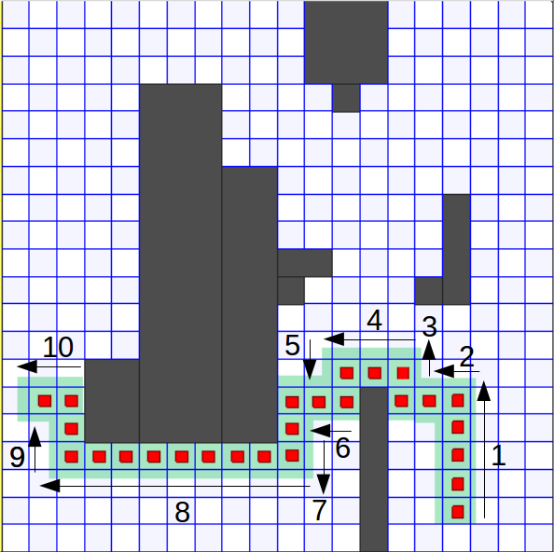

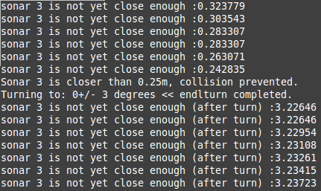
Testing the sonars

sonars used 3, 0, 7

turnTo(&robot, &pp, 180);

while(sp.GetRange(3) > 0.25){
robot.Read();
std::cout << "sonar 3 is not yet close enough :" << sp.GetRange(3) << std::endl;
pp.SetSpeed(0.1, 0);
}

pp.SetSpeed(0,0);
std::cout << "Sonar 3 is closer than 0.25m, collision prevented." << std::endl;
turnTo(&robot, &pp, 0);

while(sp.GetRange(3) > 0.25){
robot.Read();
std::cout << "sonar 3 is not yet close enough (after turn) :" << sp.GetRange(3) << std::endl;
pp.SetSpeed(0.1, 0);
}
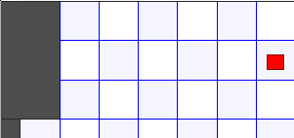
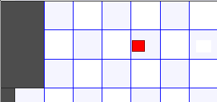
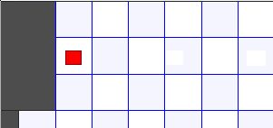

Goes back to start, infinite loop :)

After turn

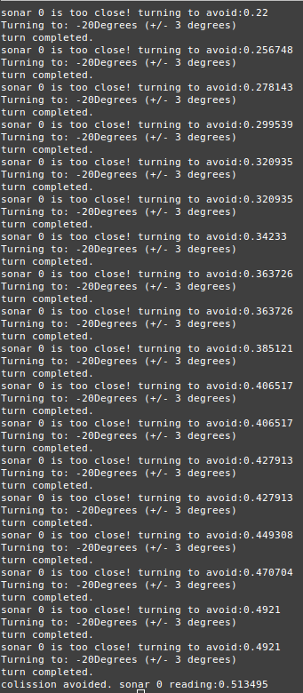
tesing sonar 0

while(sp.GetRange(0) < 0.5){
robot.Read();
std::cout << "sonar 0 is too close! turning to avoid:" << sp.GetRange(0) << std::endl;
turnTo(&robot, &pp, -20);
if(sp.GetRange(0) > 0.5);
pp.SetSpeed(0.1, 0);
}
std::cout << "colission avoided. sonar 0 reading:" << sp.GetRange(0) << std::endl;

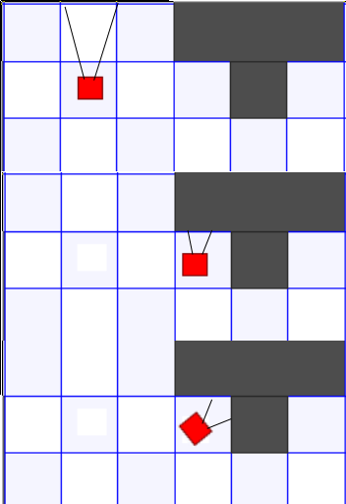
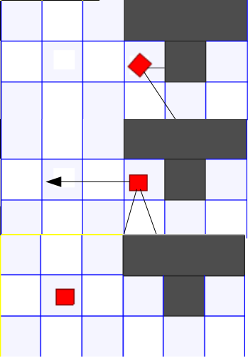

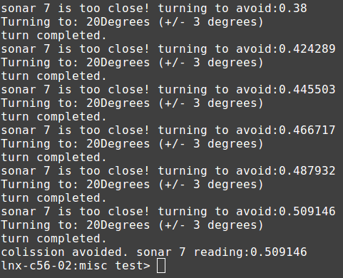

testing sonar 7:

while(sp.GetRange(7) < 0.5){
robot.Read();
std::cout << "sonar 7 is too close! turning to avoid:" << sp.GetRange(7) << std::endl;
turnTo(&robot, &pp, 20);
if(sp.GetRange(7) > 0.5);
pp.SetSpeed(0.1, 0);
}
std::cout << "colission avoided. sonar 7 reading:" << sp.GetRange(7) << std::endl;

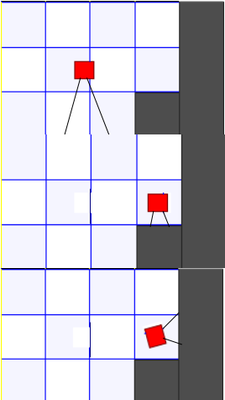
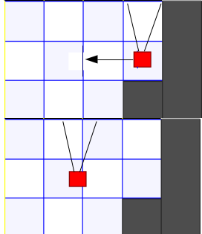

Testing move X:

if (distance > 0.05) {
turnTo(robot, pp, 0);
} else if (distance < 0) {
turnTo(robot, pp, 180);
} else {
return;
}
targetX = startX + distance;

cout << "startX : " << startX << "\n";
cout << "desitnation X : " << targetX << endl;

while (true) {

robot->Read();
double currentX = pp->GetXPos();
double xDiff;

if (targetX > currentX) {
xDiff = targetX - currentX;
} else {
xDiff = currentX - targetX;
}
difference = abs(targetX - currentX);

difference = xDiff;
cout << "difference : xDiff: " << difference << " " << xDiff << endl;
if (difference < 0) {
difference = abs(xDiff);
}
if (difference < 0.05) {
pp->SetSpeed(0, 0);
return;
}
if (sp->GetRange(3) < 0.500) {
pp->SetSpeed(0, 0);
} else {
pp->SetSpeed(0.1, 0);
}
cout << "Sonar 3: " << sp->GetRange(3) << endl;
}

Now calling this function (move forward 1 and backwards 1 to end up is the same posotion-ish)

moveDistanceAlongX(&robot, &pp, &sp, -1);
moveDistanceAlongX(&robot, &pp, &sp, 1);

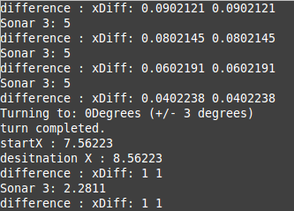
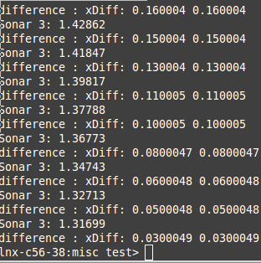
…. MOST PRINTS REMOVED BUT THIS SHOWS THE ROBOT MOVING THE OTHER WAY

The Y move fucntion is identical to X but this differs:

if (distance > 0.05) {
turnTo(robot, pp, 90);
//face up
} else if (distance < 0) {
turnTo(robot, pp, 270); // face down

} else {
return;
}

apart from this the code is the same, and so is the console apart just subsitute the xDifffor yDiff and the getX for getY

Combing these to make a draw sqaure function:

void drawSquare(PlayerClient *robot, Position2dProxy *pp, RangerProxy *sp) {

moveDistanceAlongX(robot, pp, sp, -2);
moveDistanceAlongY(robot, pp, sp, 2);
moveDistanceAlongX(robot, pp, sp, 2);
moveDistanceAlongY(robot, pp, sp, -2);

}

and is called:

drawSquare(&robot, &pp, &sp);

produced the same console output as the move and and move respectively

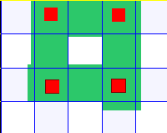
1
2
1
3
4

